Private Cloud

🔒 Definition of Private Cloud
# Source: AI Source: Provided by: [Data Path: Persons Table -> ID Column: 1, Name_En Column: Motasem Essam] -> From: [ChatGPT] on [1/26/2026]
A Private Cloud is a cloud computing model where the infrastructure is dedicated to a single organization. It can be hosted on-premises within the organization’s data center or by a third-party provider, but the key is that resources are not shared with other organizations.
Key points:
- Provides exclusive access to computing resources for one organization.
- Offers higher control and security compared to public cloud.
- Often used by organizations with strict compliance, privacy, or regulatory requirements.

⚙️ Features of Private Cloud
# Source: AI Source: Provided by: [Data Path: Persons Table -> ID Column: 1, Name_En Column: Motasem Essam] -> From: [ChatGPT] on [1/26/2026]
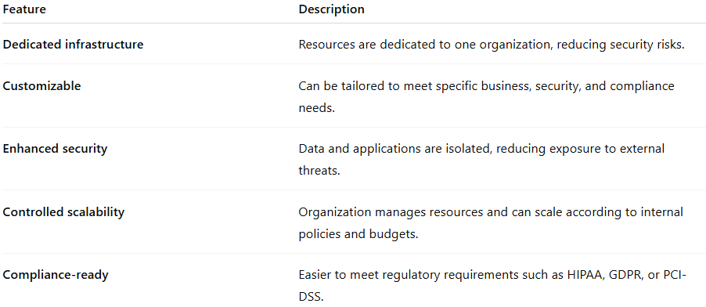
Feature | Description
Dedicated infrastructure | Resources are dedicated to one organization, reducing security risks.
Customizable | Can be tailored to meet specific business, security, and compliance needs.
Enhanced security | Data and applications are isolated, reducing exposure to external threats.
Controlled scalability | Organization manages resources and can scale according to internal policies and budgets.
Compliance-ready | Easier to meet regulatory requirements such as HIPAA, GDPR, or PCI-DSS.

✅ Advantages of Private Cloud
# Source: AI Source: Provided by: [Data Path: Persons Table -> ID Column: 1, Name_En Column: Motasem Essam] -> From: [ChatGPT] on [1/26/2026]
- High security: Dedicated resources minimize exposure to external threats.
- Greater control: Organizations control hardware, network, and storage configurations.
- Customization: Tailor infrastructure to specific workloads and compliance needs.
- Performance reliability: No resource contention with other organizations.
- Regulatory compliance: Easier to comply with industry-specific laws and standards.

⚠️ Disadvantages / Challenges
# Source: AI Source: Provided by: [Data Path: Persons Table -> ID Column: 1, Name_En Column: Motasem Essam] -> From: [ChatGPT] on [1/26/2026]
- Higher cost: Requires investment in hardware, maintenance, and management.
- Management complexity: IT staff must manage, update, and secure the infrastructure.
- Limited scalability: Scaling requires additional physical resources and planning.
- Longer deployment time: Setting up a private cloud takes more time compared to public cloud.

🛠️ Private Cloud Service Models
# Source: AI Source: Provided by: [Data Path: Persons Table -> ID Column: 1, Name_En Column: Motasem Essam] -> From: [ChatGPT] on [1/26/2026]
Private clouds can also provide the same service models as public clouds but in a dedicated environment:
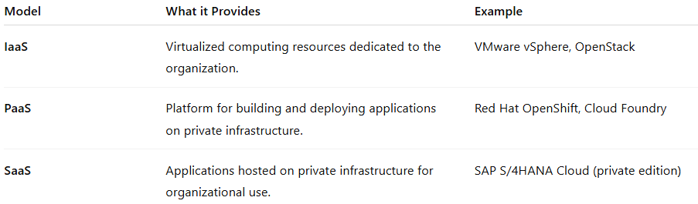
Model | What it Provides | Example
IaaS | Virtualized computing resources dedicated to the organization. | VMware vSphere, OpenStack
PaaS | Platform for building and deploying applications on private infrastructure. | Red Hat OpenShift, Cloud Foundry
SaaS | Applications hosted on private infrastructure for organizational use. | SAP S/4HANA Cloud (private edition)

🌐 Examples of Private Cloud Solutions
# Source: AI Source: Provided by: [Data Path: Persons Table -> ID Column: 1, Name_En Column: Motasem Essam] -> From: [ChatGPT] on [1/26/2026]
- VMware vSphere / VMware Cloud Foundation – widely used for on-premises private cloud.
- OpenStack – open-source platform for building private clouds.
- Microsoft Azure Stack – brings Azure services into on-premises private clouds.
- IBM Cloud Private – enterprise-focused private cloud solution.

📝 Use Cases of Private Cloud
# Source: AI Source: Provided by: [Data Path: Persons Table -> ID Column: 1, Name_En Column: Motasem Essam] -> From: [ChatGPT] on [1/26/2026]
- Organizations handling sensitive or regulated data, e.g., healthcare, finance.
- Enterprises requiring full control over infrastructure and performance.
- Development and testing environments where custom configurations are needed.
- Workloads with predictable resource usage or long-term, mission-critical applications.

📌 Summary
# Source: AI Source: Provided by: [Data Path: Persons Table -> ID Column: 1, Name_En Column: Motasem Essam] -> From: [ChatGPT] on [1/26/2026]
The Private Cloud is a dedicated cloud environment designed for a single organization, offering high security, control, and compliance. While it comes with higher costs and management complexity, it is ideal for organizations with sensitive data, regulatory requirements, or custom infrastructure needs. Private cloud solutions support IaaS, PaaS, and SaaS, and popular platforms include VMware, OpenStack, Azure Stack, and IBM Cloud Private.

